Sun Young Park

Below are plots using the US data that was processed and delivered by the CGA

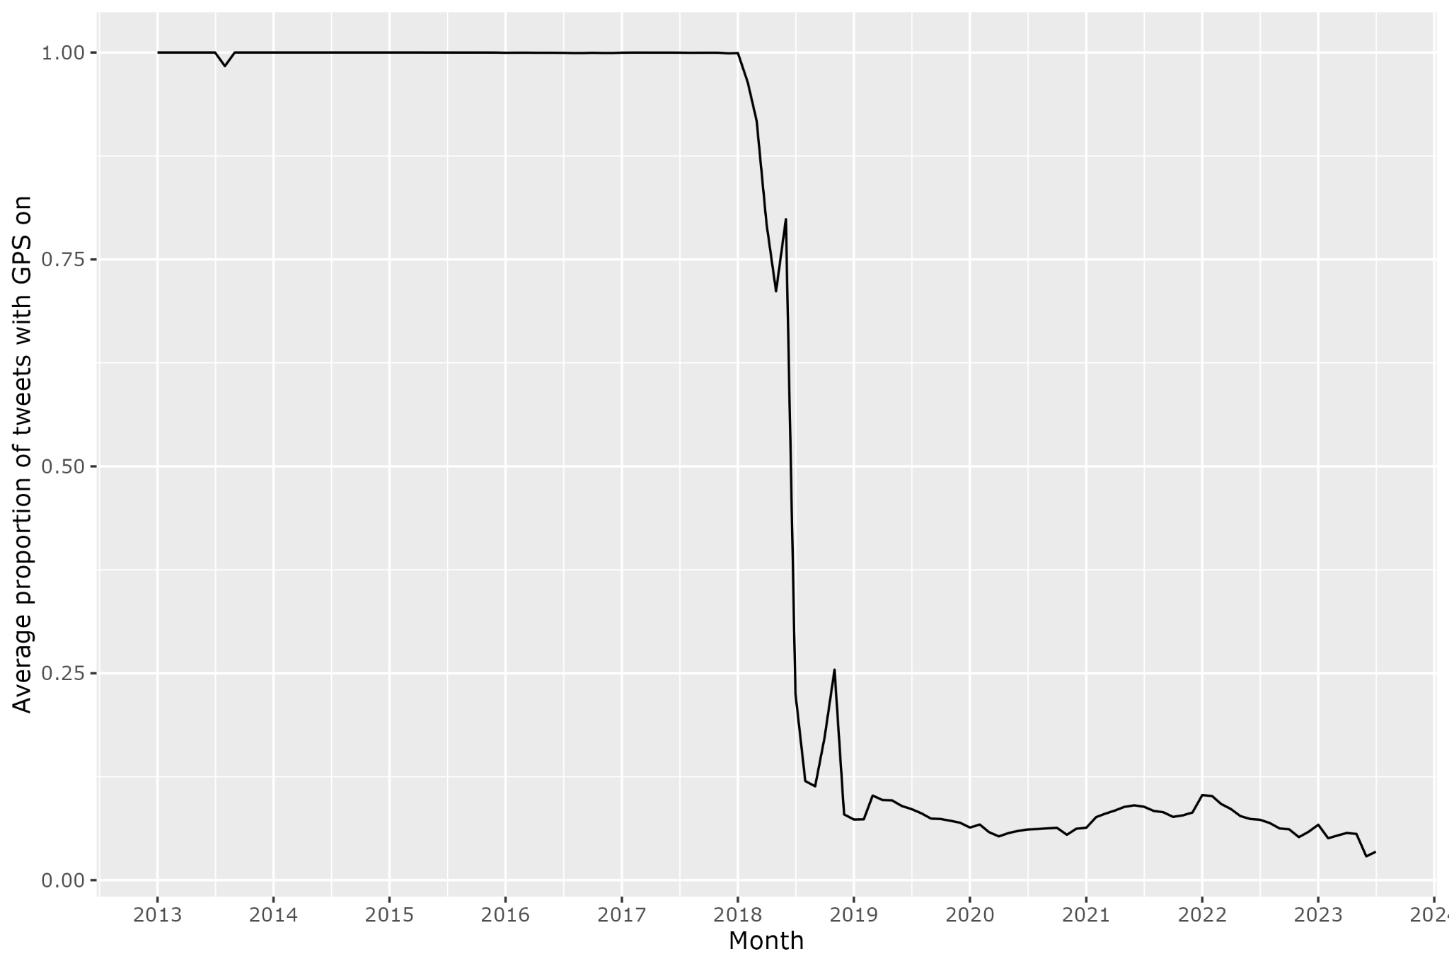

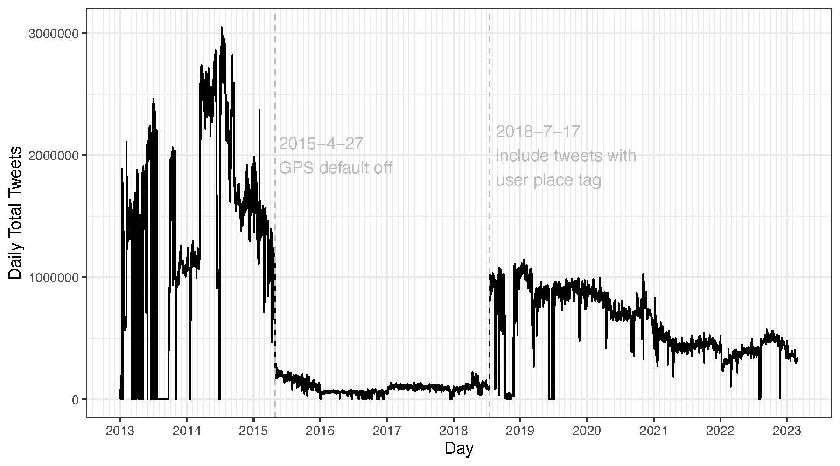

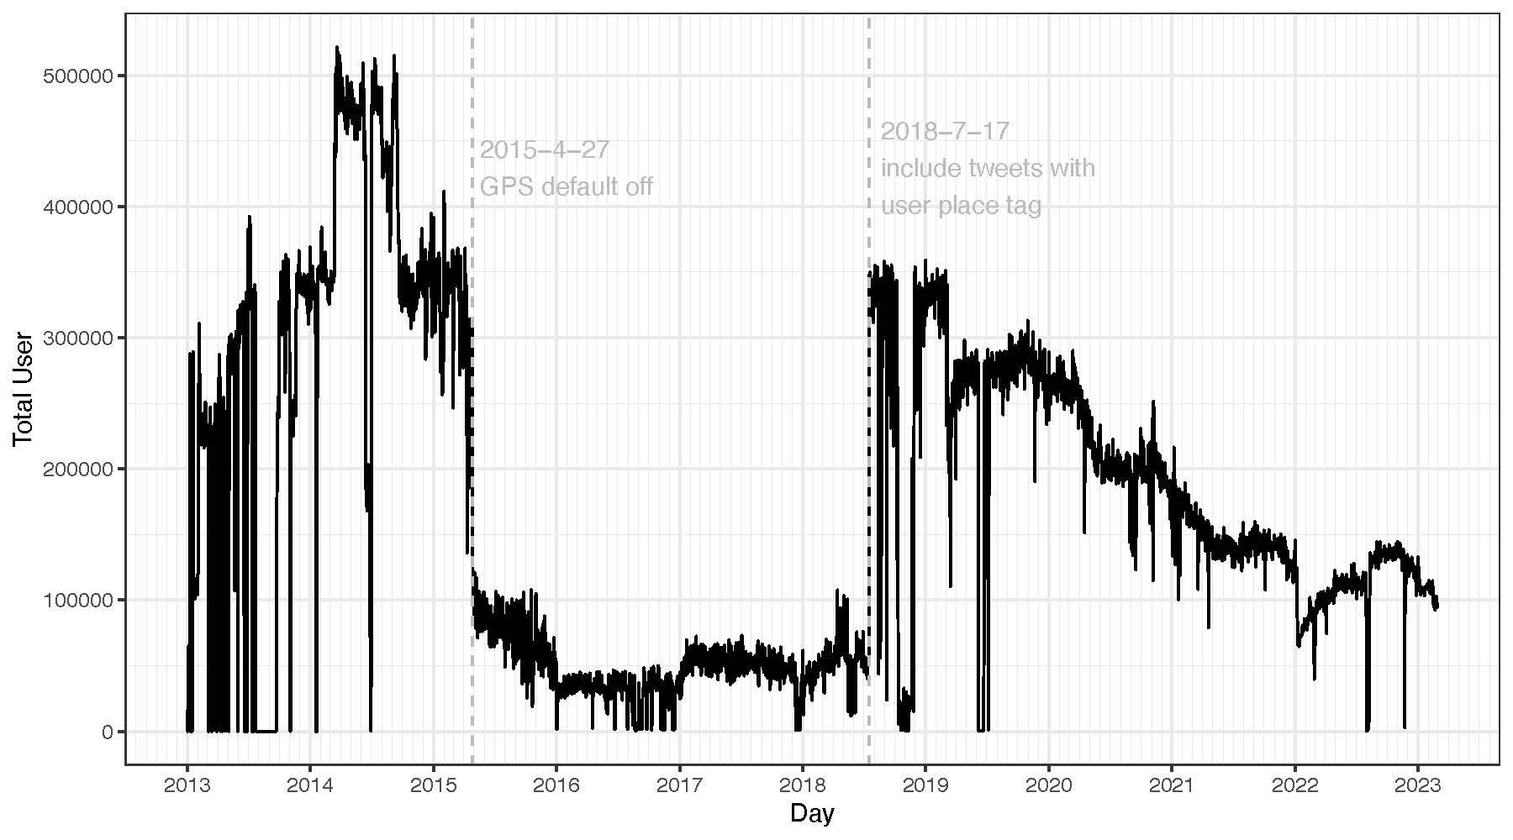

Below are plots using French data that were extracted this year show similar patterns.

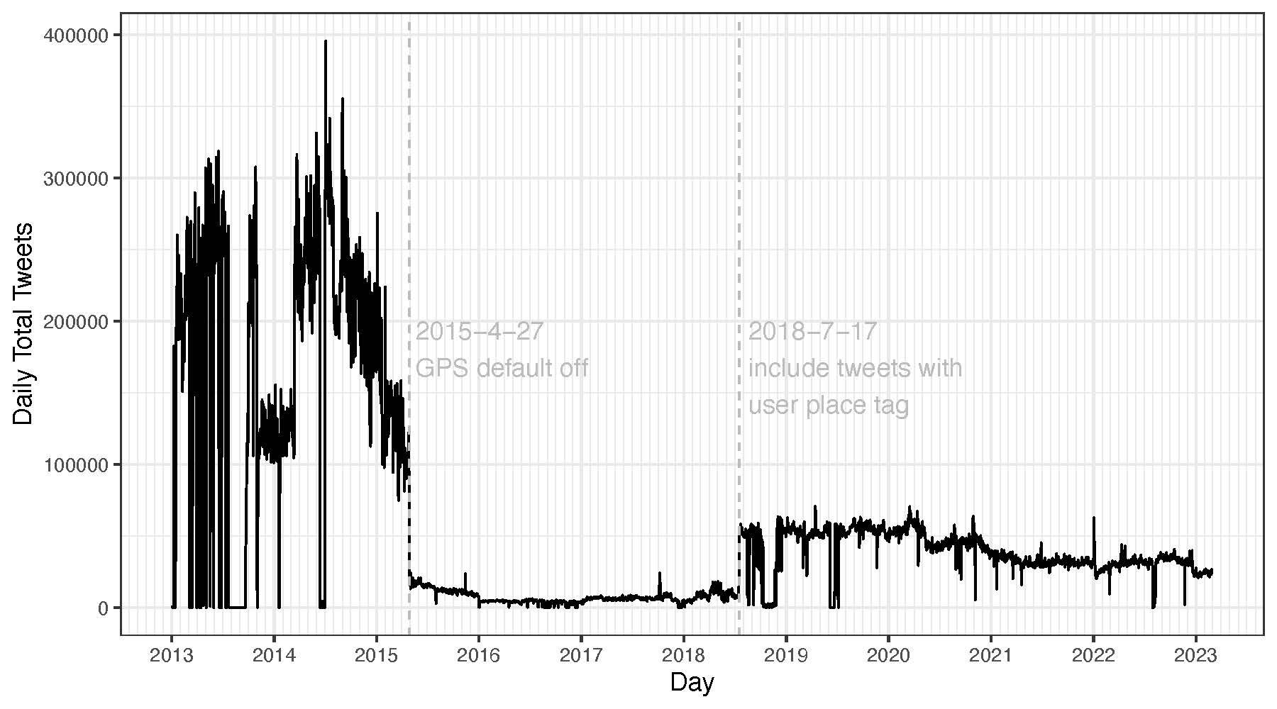

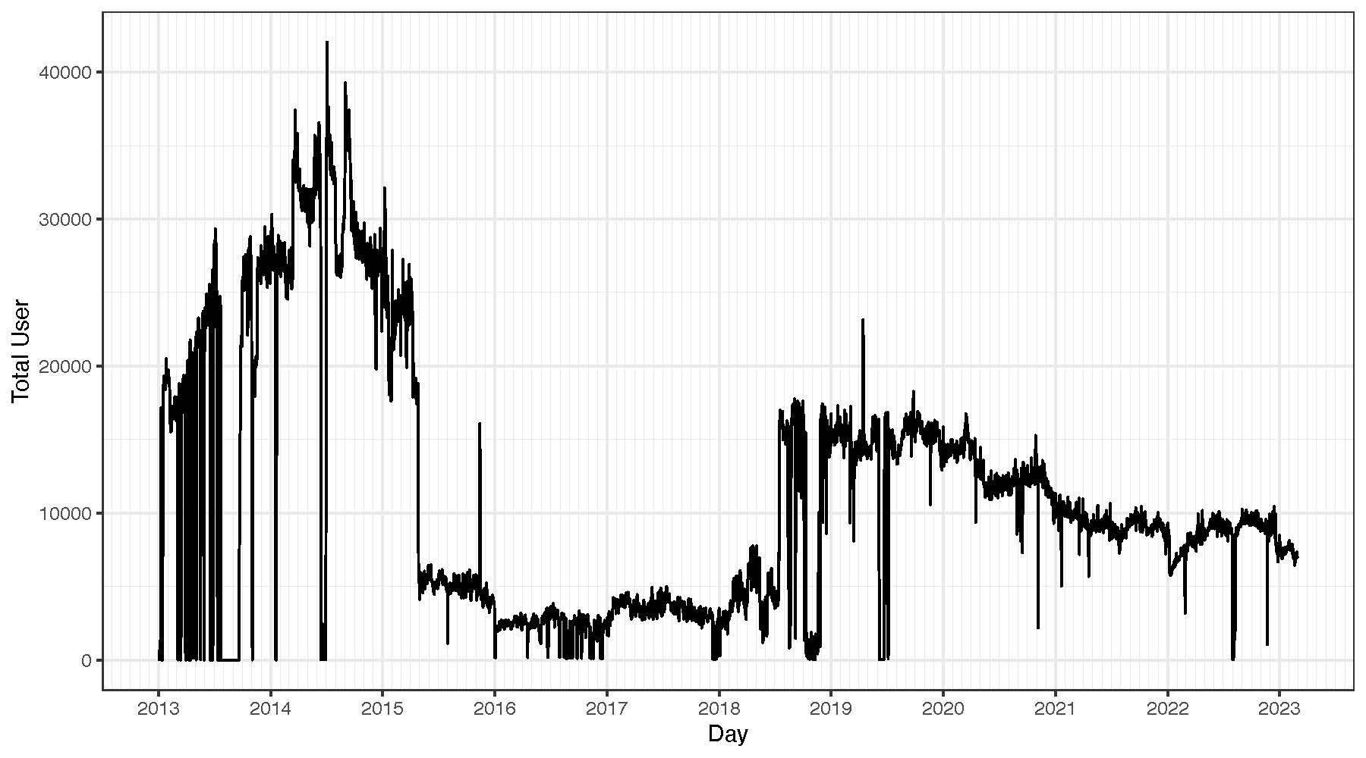

Below are dates with pulling errors per country.

* Some errors seem to have led to 0 tweet harvested that day and others led to a significantly smaller number of tweets than the dates around it but still more than a dozen thousands of tweets a day. I include dates that had less than around 1% tweets than the surrounding dates below. And I also listed in the parenthesis dates that had 1-10% of tweets compared to the surrounding dates but based on the pattern, it looks like there were some pulling issues some part of the day. The years that are not listed below had no pulling errors.
* The pulling errors seem to have happened on similar dates for both the U.S. and France. They differ slightly probably because the pulling was run per continent and sometimes some of them might have been affected and others not.

Dates with pulling errors for the U.S.

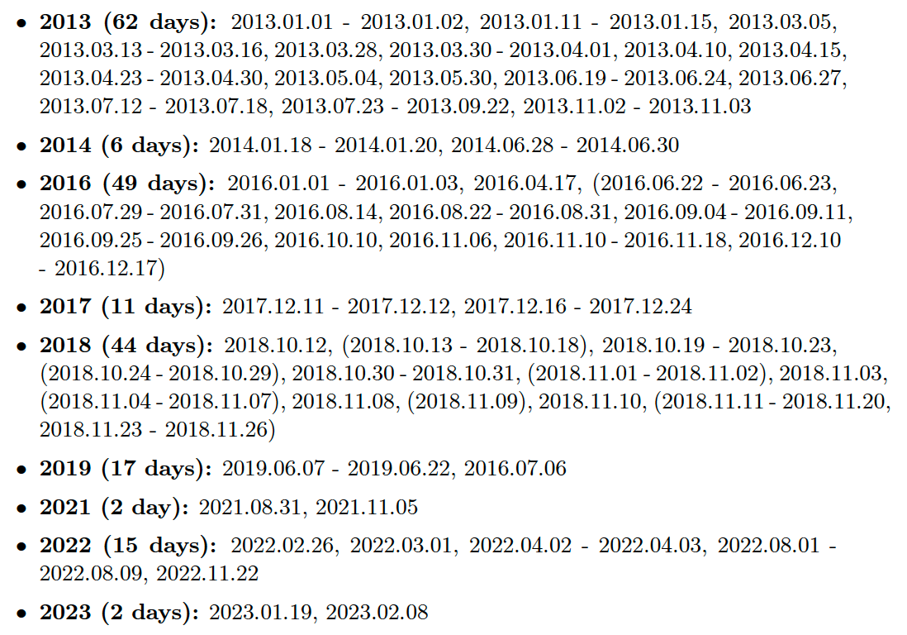

Dates with pulling errors for France

